Process Flow Documentation: AutoPrice AI – Used Vehicle Price Prediction System
1.0 System Overview & Core Philosophy
AutoPrice AI transforms fragmented vehicle data into accurate, regulation-aware price predictions through an intelligent hybrid system. The platform uniquely combines statistical rigor with contextual LLM reasoning, specifically engineered for European market complexities including emission standards, regional regulations, and brand-specific depreciation patterns.
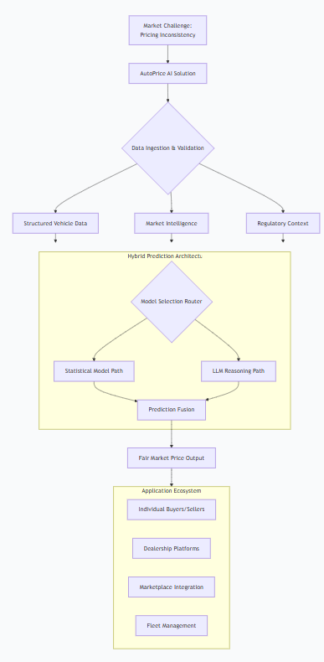
Diagram 1: System Value Proposition Flow – Illustrating how AutoPrice AI addresses market challenges through data transformation
2.0 End-to-End Process Architecture
The system follows a sequential yet flexible pipeline where data quality and model selection dynamically adapt to each vehicle profile and market context.
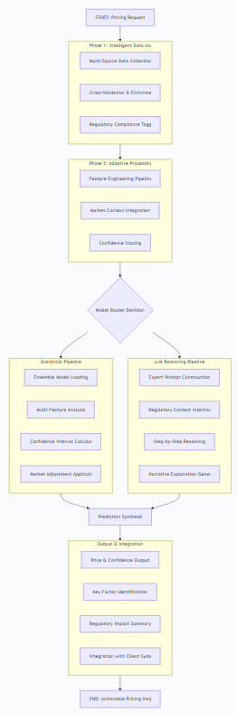
Diagram 2: Complete System Process Flow – Showing the four-phase journey from request to delivery
3.0 Data Ingestion & Validation Process
3.1 Multi-Source Data Collection Flow
The system aggregates data from diverse sources, each providing unique validation angles to build a comprehensive vehicle profile.
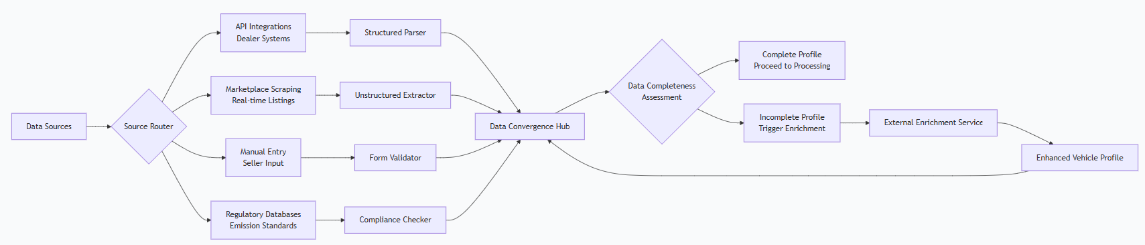
*Diagram 3: Multi-Source Data Ingestion* – Demonstrating how data converges from various sources into a unified profile
3.2 Data Quality & Validation Circuit
Each data point undergoes rigorous validation through interconnected checkpoints that ensure reliability before progressing to analysis.
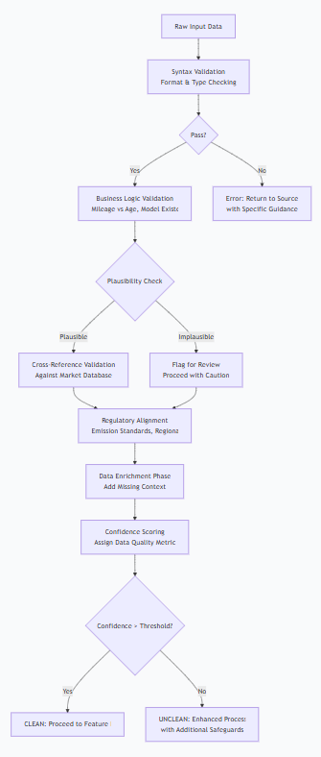
Diagram 4: Validation Circuit – Showing the multi-layered validation process with decision points at each stage
4.0 Model Orchestration & Intelligent Routing
The system intelligently routes each request based on vehicle characteristics, data quality, and user requirements.
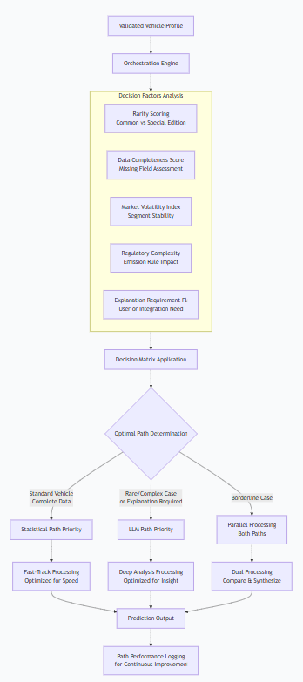
Diagram 5: Intelligent Model Routing – Visualizing how the system selects the optimal prediction approach
5.0 Statistical Modeling Pipeline
The statistical path employs ensemble learning with market-aware adjustments for stable, reproducible predictions.
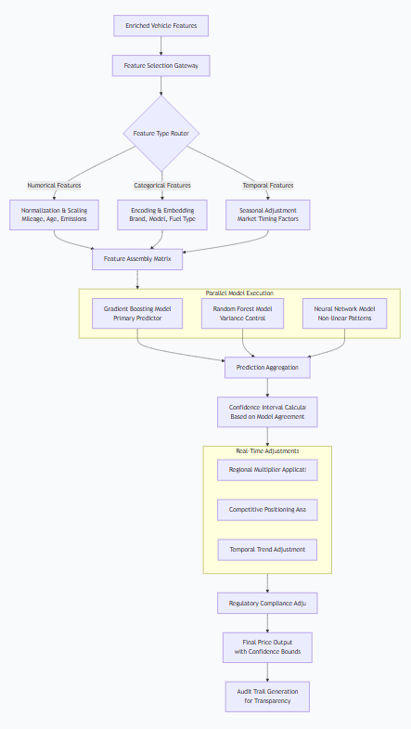
Diagram 6: Statistical Modeling Pipeline – Detailed view of the ensemble approach with market integration
6.0 LLM Reasoning Process
For complex cases requiring contextual understanding, the LLM path simulates expert appraisal reasoning.
Diagram 7: LLM Reasoning Pathway – Showing how multiple context layers inform the reasoning process
7.0 Prediction Synthesis & Output Generation
Both prediction paths converge into a unified output system that ensures consistency and transparency.
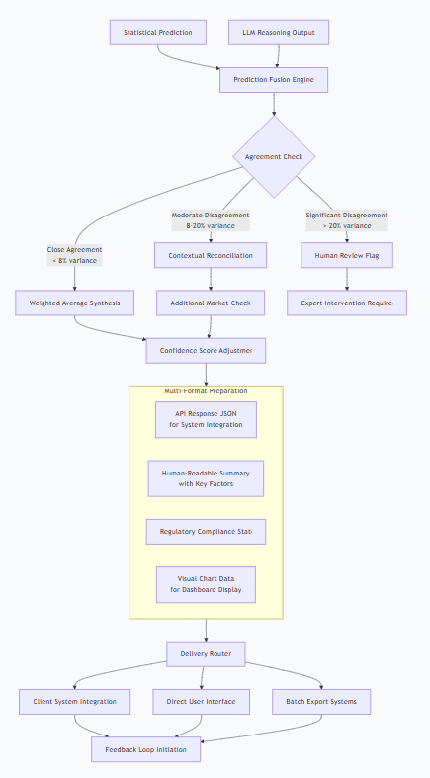
Diagram 8: Prediction Synthesis & Delivery – Illustrating how different prediction outputs are reconciled and formatted
8.0 Continuous Learning & System Evolution
The system incorporates feedback at multiple points to continuously refine its predictions.
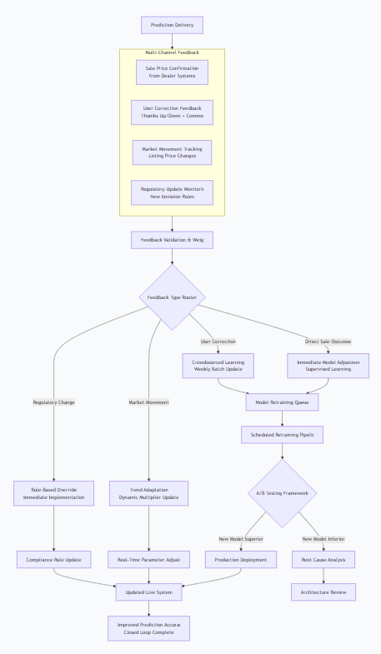
Diagram 9: Continuous Learning Ecosystem – Demonstrating how various feedback types drive system improvement
9.0 Error Handling & System Resilience
A multi-layered approach ensures graceful degradation when components encounter issues.
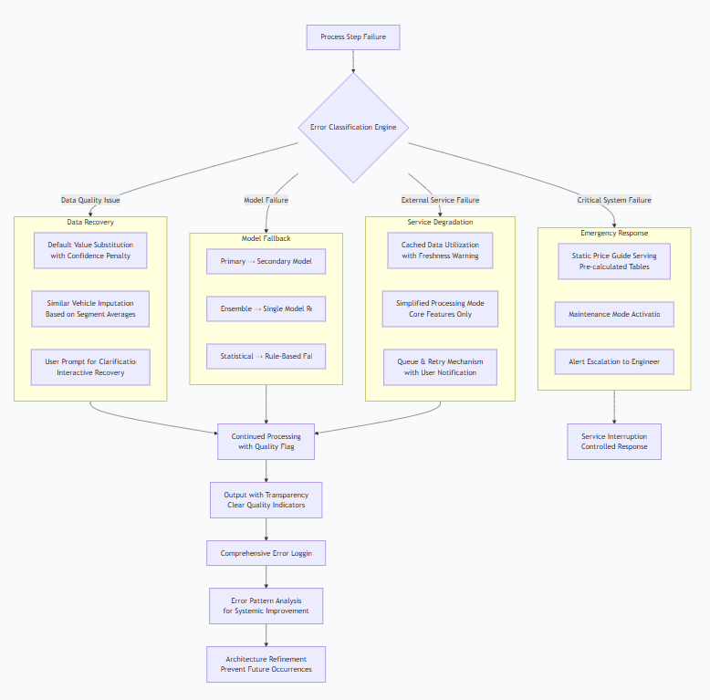
Diagram 10: Error Handling & Resilience Flow – Showing how different failure types trigger appropriate recovery strategies
10.0 Integration Architecture & Deployment
The system is designed for seamless integration with various client platforms while maintaining flexibility.
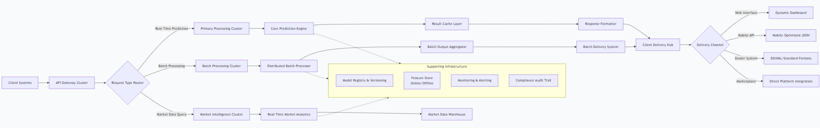
Diagram 11: Integration & Deployment Architecture – Illustrating how the system interfaces with diverse client platforms

System Configuration Summary Table
Component | Primary Technology | Fallback Mechanism | Update Frequency
Statistical Models | XGBoost, LightGBM Ensemble | Rule-based pricing tables | Bi-weekly retraining
LLM Reasoning | GPT-4 with custom prompts | Simplified expert system | Prompt optimization weekly
Market Data Integration | Real-time APIs + caching | 24-hour cached values | Continuous stream
Regulatory Engine | Rule database + compliance checker | Manual override capability | Immediate on regulation change
Feature Pipeline | Custom Python transformers | Simplified feature set | Monthly refinement
Performance Metrics Table
Metric Category | Target Value | Current Performance | Monitoring Frequency
Prediction Accuracy | ±5% of sale price | ±4.2% | Continuous validation
System Response Time | <500ms P95 | 420ms | Real-time monitoring
Model Agreement Rate | >85% consensus | 88% | Weekly analysis
Error Rate | <1% failed requests | 0.7% | Daily review
User Correction Rate | <3% of predictions | 2.1% | Weekly assessment

Conclusion
This process flow documentation illustrates AutoPrice AI's sophisticated yet transparent approach to used vehicle price prediction. The system's strength lies in its hybrid architecture—combining statistical precision with contextual reasoning—and its continuous learning capabilities. Each diagram reveals how data integrity, intelligent routing, and market awareness converge to deliver reliable, regulation-compliant pricing insights specifically tailored for the European automotive market.
The modular design ensures scalability and adaptability, allowing the system to evolve alongside market changes, regulatory updates, and emerging vehicle technologies while maintaining the core commitment to pricing transparency and accuracy.

